ADB PROJECT
- CREATE DATABRICKS
- CREATE ADF-create compute
- CREATE ADLS STORAGE ACCOUNT
Container1/landing/mysql_sources
- CREATE INTEGRATION RUNTIME- for Mysql connection
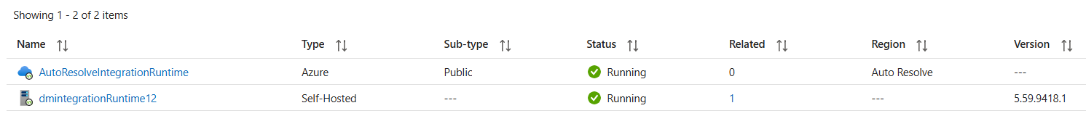

- WE NEED 4 LINKED SERVICES
- ADF TO ADB
- Compute/databricks
- 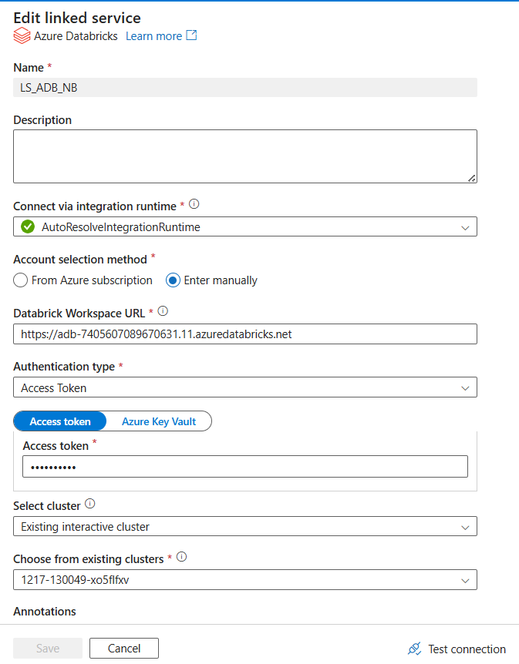

- DATABRICKS
-LS_SOURCE_ADB_LOOKUP
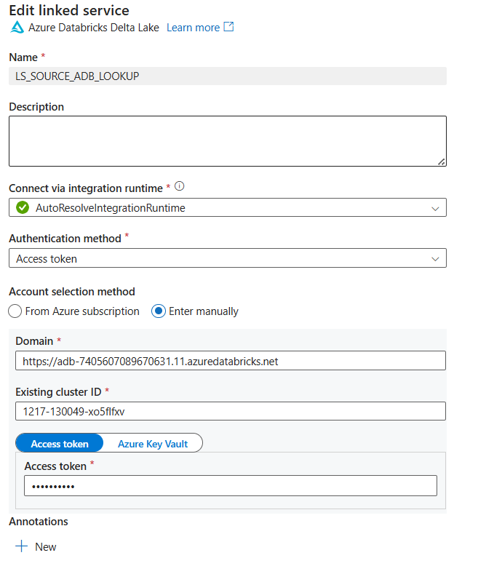
- MYSQL
-ADD PARAMETERS(server_name,pass,user_name,db_name,port_no)
-LS_SOURCE_MYSQL_COPYACTIVITY
-ADD CUSTOME IR
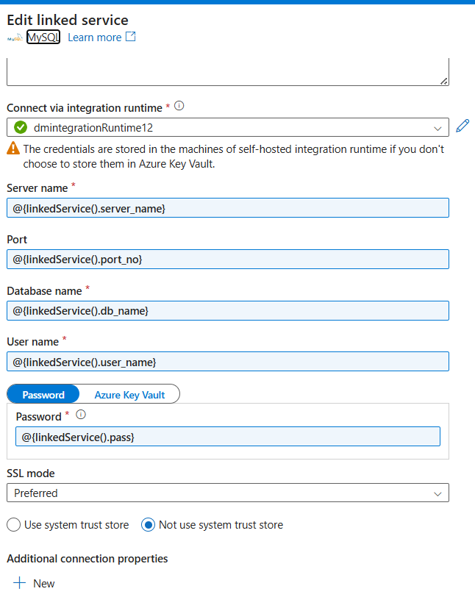
- ADLS
- LS_SINK_ADLS_COPYACTIVITY
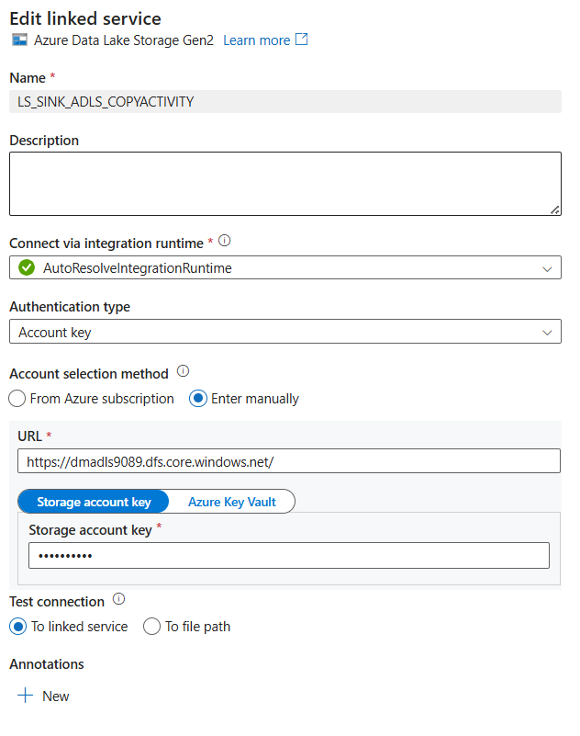
WE NEED 3 DATASETS
- LOOKUP
-DS_SOURCE_DATALAKE_LOOKUP
-NEED TO PASS THE DB_NAME AND TABLE_NAME
- here we have created the view of joining cred_metadata and table_metadata
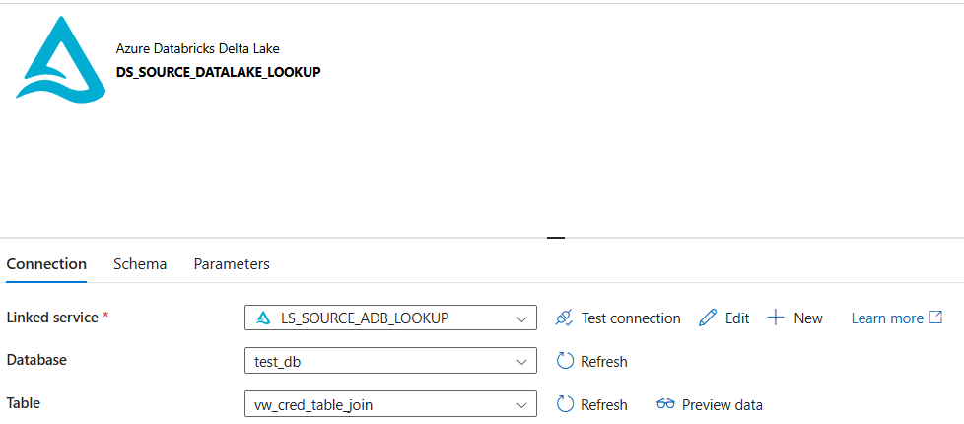
- SOURCE_COPY
-DS_SOURCE_MYSQL_COPYACTIVITY
-ADD DATASET LEVEL PARAMETERS TO PASS THE VALUES TO THE LINKEDLIST LEVEL PARAMETERS
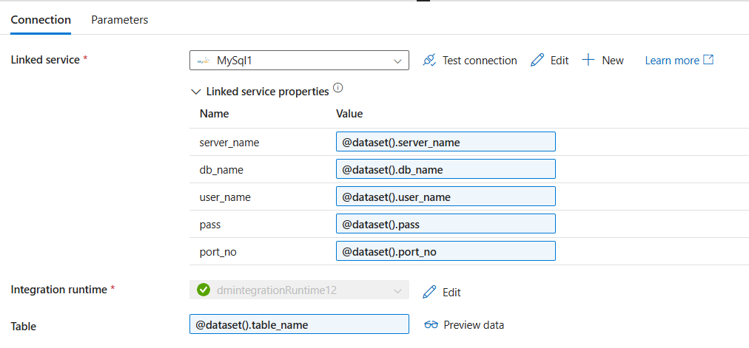
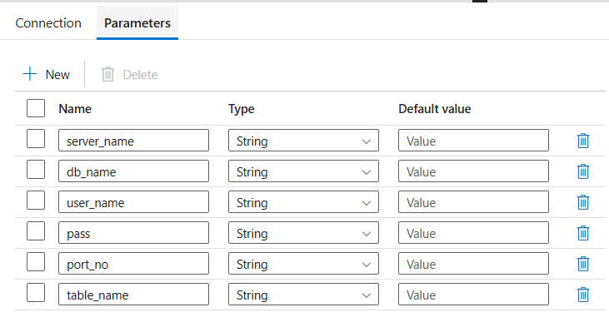
- SINK_COPY
-DS_SINK_ADLS_COPYACTIVITY
-ADD PARAMETERS container_name,path, and filename
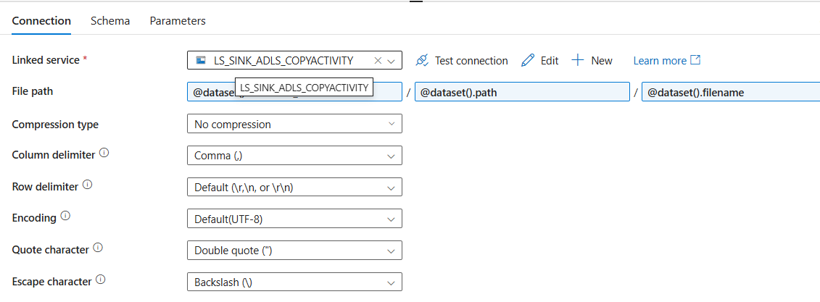

CREATE DATASETS

IN MYSQL

CREATE DATABASE test_db;
use test_db;

CREATE TABLE transaction (
tid INT PRIMARY KEY,
customer_id INT NOT NULL,
transaction_date DATETIME NOT NULL,
amount DECIMAL(10,2) NOT NULL,
payment_method VARCHAR(50),
status VARCHAR(20)
);
INSERT INTO transaction (tid, customer_id, transaction_date, amount, payment_method, status) VALUES
(101, 1, '2024-01-10 10:30:00', 450.75, 'Credit Card', 'Completed'),
(102, 2, '2024-01-12 15:45:00', 120.00, 'UPI', 'Completed'),
(103, 3, '2024-01-15 11:20:00', 950.00, 'Net Banking', 'Pending');

CREATE TABLE orders (
oid INT PRIMARY KEY,
tid INT,
product_id INT NOT NULL,
quantity INT NOT NULL,
price DECIMAL(10,2),
order_status VARCHAR(20),
FOREIGN KEY (tid) REFERENCES transaction(tid)
);
INSERT INTO orders (oid, tid, product_id, quantity, price, order_status) VALUES
(201, 101, 5001, 2, 225.38, 'Shipped'),
(202, 102, 5002, 1, 120.00, 'Delivered'),
(203, 103, 5003, 1, 950.00, 'Processing');

IN DATABRICKS

CREATE DATABASE test_db;
use test_db;
CREATE TABLE table_metadata(
tid INT,
table_name VARCHAR(200),
container_name VARCHAR(200),
path VARCHAR(100),
filename VARCHAR(100)
);

INSERT INTO table_metadata VALUES(101,'transaction','container1','landing/mysql_source','transaction.csv');
INSERT INTO table_metadata VALUES(102,'orders','container1','landing/mysql_source','orders.csv');
SELECT * FROM table_metadata;

CREATE TABLE cred_metadata(
cid INT,
tid INT,
server_name VARCHAR(100),
port_no VARCHAR(100),
db_name VARCHAR(100),
user_name VARCHAR(100),
pass VARCHAR(100)
);

INSERT INTO cred_metadata VALUES(201,101,'localhost','3306','test_db','root','password');
INSERT INTO cred_metadata VALUES(202,102,'localhost','3306','test_db','root','password');

CREATE VIEW

%sql
CREATE OR REPLACE VIEW test_db.vw_cred_table_join AS
SELECT
t.tid,
t.table_name,
t.container_name,
t.path,
t.filename,
c.cid,
c.server_name,
c.port_no,
c.db_name,
c.user_name,
c.pass
FROM cred_metadata c
JOIN table_metadata t
ON c.tid = t.tid;

OR ADD DYNAMIC QUERY

@concat(
'SELECT t.tid, table_name, container_name, path, filename, ',
'cid, server_name, port_no, db_name, user_name, pass ',
'FROM dm_ws_7405607089670631.test_db.', pipeline().parameters.cred_metadata, ' c ',
'JOIN dm_ws_7405607089670631.test_db.', pipeline().parameters.table_metadata, ' t ',
'ON c.tid = t.tid'
)

PIPELINE

- LOOKUP ACTIVITY
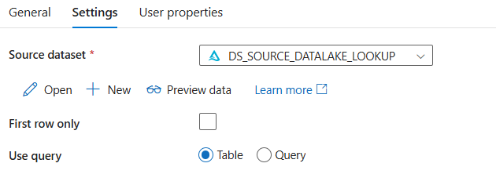

VALUES RETURNED
"value": [
{
"tid": "102",
"table_name": "orders",
"container_name": "container1",
"path": "landing/mysql_source",
"filename": "orders.csv",
"cid": "202",
"server_name": "localhost",
"port_no": "3306",
"db_name": "test_db",
"user_name": "root",
"pass": "Meghare123@+"
},
{
"tid": "101",
"table_name": "transaction",
"container_name": "container1",
"path": "landing/mysql_source",
"filename": "transaction.csv",
"cid": "201",
"server_name": "localhost",
"port_no": "3306",
"db_name": "test_db",
"user_name": "root",
"pass": "Meghare123@+"
}

- FOR EACH
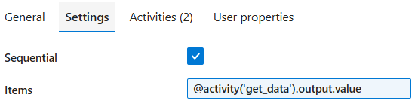
- COPY DATA
-SOURCE
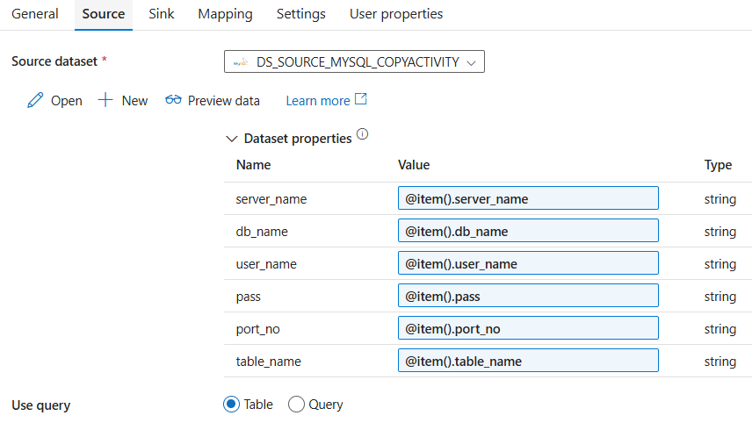
-SINK
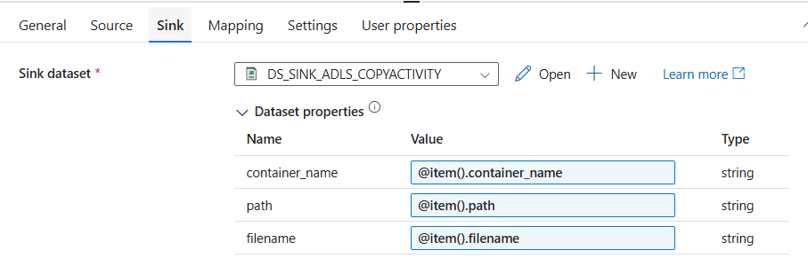
- NOTEBOOK ACTIVITY

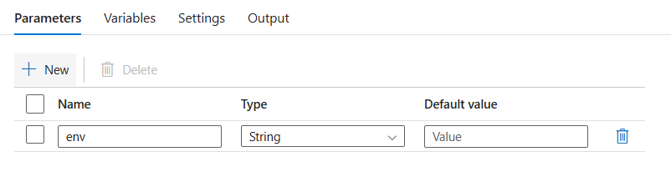

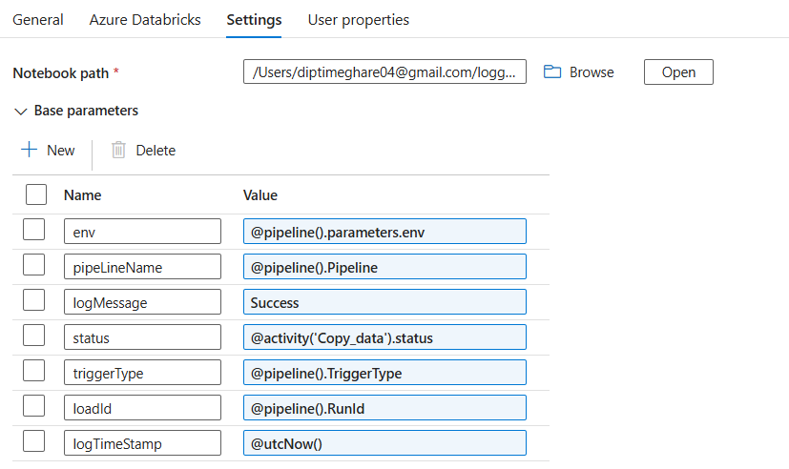

NOTEBOOK SETUP

# Databricks notebook source
dbutils.widgets.text("env", "")
env = dbutils.widgets.get("env")

spark.sql(f"""
create database if not exists {env}_log
""")

spark.sql(f"""
create or replace table {env}_log.log_record_tbl (
env string,
pipeLineName string,
logMessage string,
status string,
triggerType string,
loadId string,
logTimeStamp timestamp
)
""")

df = spark.sql(f"""
select * from {env}_log.log_record_tbl
""")
df.show()

insert_logs notebook
#creating widgets to get the parameters
dbutils.widgets.text("env","")
dbutils.widgets.text("pipeLineName","")
dbutils.widgets.text("logMessage","")
dbutils.widgets.text("status","")
dbutils.widgets.text("triggerType","")
dbutils.widgets.text("loadId","")
dbutils.widgets.text("logTimeStamp","")

#Creating Variables for Wedgts
env=dbutils.widgets.get("env")
pipeLineName=dbutils.widgets.get("pipeLineName")
logMessage=dbutils.widgets.get("logMessage")
status=dbutils.widgets.get("status")
triggerType=dbutils.widgets.get("triggerType")
loadId=dbutils.widgets.get("loadId")
logTimeStamp=dbutils.widgets.get("logTimeStamp")

#To escape single quotes, use back slash(\)
status = status.replace('\'','"')

#Updating the pipeline run status to log table
spark.sql(f"""insert into {env}_log.log_record_tbl values ('{env}','{pipeLineName}','{logMessage}','{status}','{triggerType}','{loadId}',cast('{logTimeStamp}' as Timestamp))""")

OUTPUT

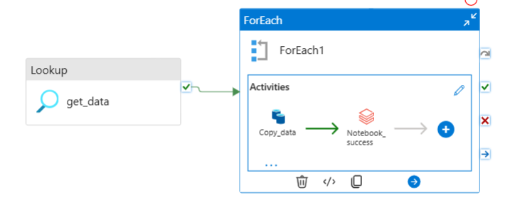

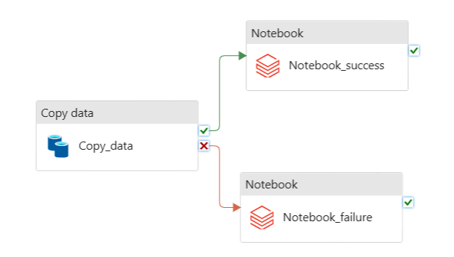

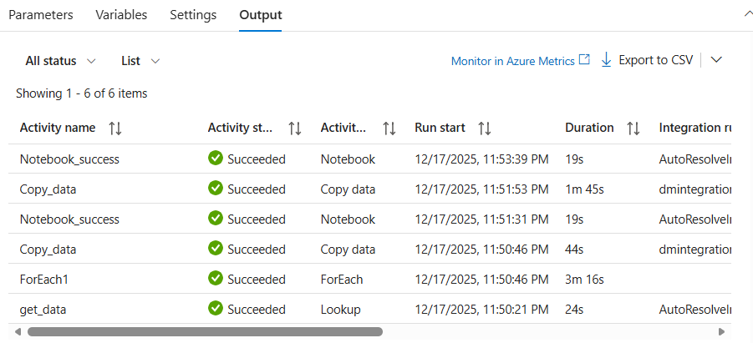

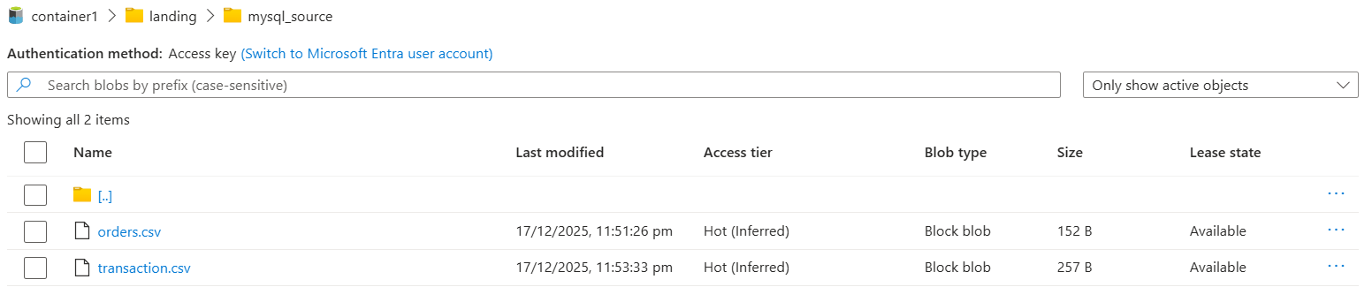

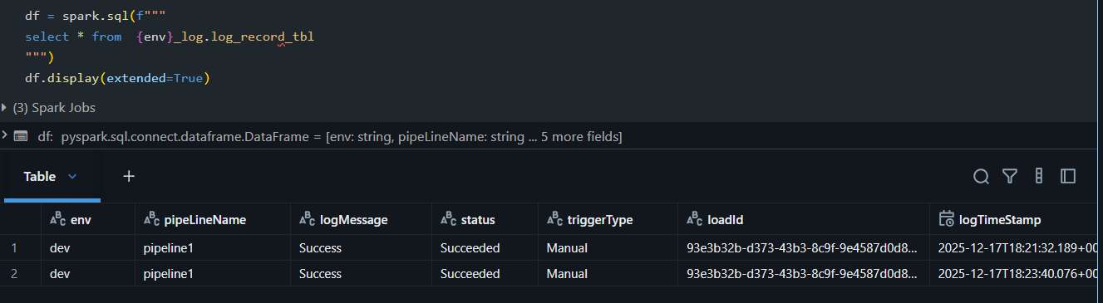

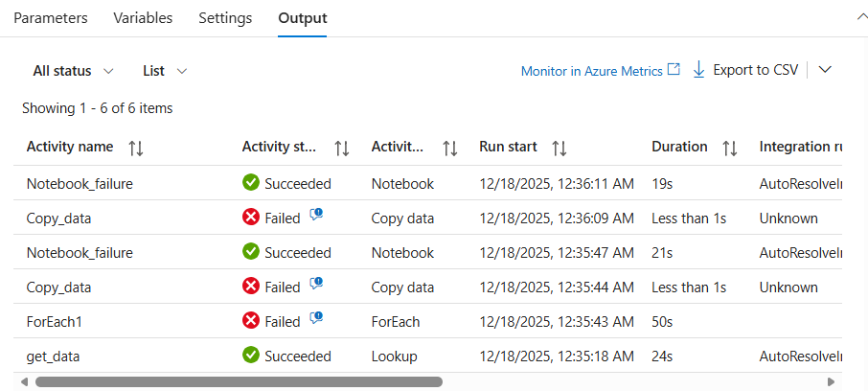

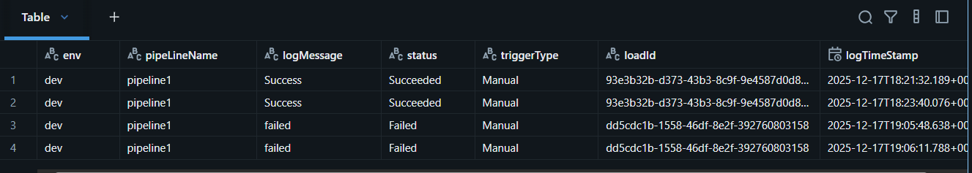

NOTE:
NOTEBOOK PARAMTER NAMES MUST BE SAME AS VARIABLE NAMES IN THE DATABRICKS NOTEBOOK.
TRY TO KEEP CONSISTENCY IN THE PARAMTER NAMES IT REDUCE THE CONFUSION

